**SQL MURDER MYSTERY**

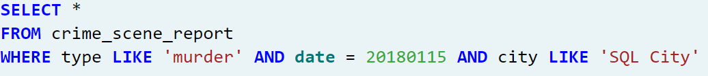

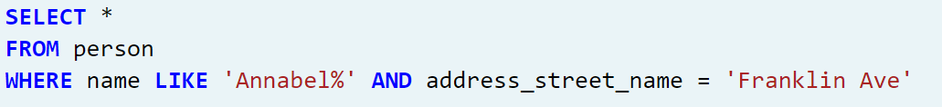



**Solution**

Tushar and Jeremy are the two people with their vehicle plate numbers that includes H42W as mentioned by the witness Morty Shapiro. The other witness, Annabel Miller stated that she saw the killer in her gym on January 9th. Tushar is not even a member of the gym which proves that Jeremy is the killer.

SUBMITTED BY,

ANN TRESA THOMAS (REG.NO. 2237025)